2024 SALT 66 Magnetic Island to Townsville Swim
RACE BRIEFING
There will be no presentation of the race briefing this year. Please read this document carefully. A list of frequently asked questions has also been prepared.
Race organisers will be available at the Swimmers Check-In on Friday afternoon, 19 July 2024 at The Drill Hall Studio, 27 Mitchell St North Ward,Townsville, from 4pm if you have further questions.
All swimmers should attend the check-in to receive their race pack including swim cap, timing chip and paddler number. Paddlers and Boat Skippers are welcome to come along.

CONTENTS
- Declaration
- Swimmer’s Bag & Paddler Pack
- Swim Suits & Rules
- Safety & Communications
- Hazards & Weather
- Getting to the Start
- The Course
- Start - Finish
- Presentations

ON-LINE DECLARATION
By entering this Race you have agreed to abide by the Race rules and accept the terms and conditions for the Swim, contained therein.
It is also accepted that you have read and understood the information contained in the Swimmer's Declaration Form as well as the COVID-19 TERMS AND CONDITIONS OF ENTRY AND ATTENDANCE AT EVENTS and accept these terms and conditions.

SWIMMERS BAG & PADDLER PACK
Every Swimmer should attend check-in on Friday afternoon 19 July 2024 at The Drill Hall Studio 27 Mitchell St Nort Ward, Townsville from 4pm to receive a bag containing:
  - 2024 Magnetic Is swim cap
Each solo swimmer and one per Duo / Team will receive a pack containing:
  - Tow float – (2 for duos and relays)
  - 2 Paddler Numbers, Pins & Flag
  - Timing Chip
On Saturday morning, at the Sealink Ferry Terminal, each solo and one per duo/team will be given their ferry ticket. E-tickets may be in place. No bus ticket is required – just follow Colette.
A swimmers pack will be presented at the finish line containing towel, shirt and other material.
SWIM SUIT & RULES
- As per race rules swimmers must wear one suit only
- Swimmer must wear the race cap. A second cap may be worn underneath
- Swimmer must attach the tow float when swimming
- Wetsuit category applies if your swim suit is not compliant with Swimming Australia Open Water Swimwear rules and Inclusive Swimwear Policy. Check with the Race Director if you are unsure.
- No interference with others
- No drafting off or being towed by craft
- Paddlers should be careful not to impede an overtaking swimmer
- Paddler support if needed
- Duos & Team can change-over whenever they decide. Just do it safely.
- Maritime Safety Queensland has issued an Aquatic Event Permit for the swim and we must comply with the conditions of the permit including race cut-off times.

SAFETY
- Solo swimmers must Have Paddler, and may share a paddler if swimmers are a similar speed
- Teams Must Have Paddler & Support Boat
- Everyone must follow directions of TOWSA officials
- TARC providing race communications
- Base Mobile Phone 0419 655 940
- Start Line 0407 262 322
- On Water Official 0407 391 974
- Marine Radio VHF Channels to be used are:
- SLSC IRBs
  - Ch 16 Emergency calling only
  - Ch 22 Reporting In and Coastguard
  - Ch 73 For all other Reports and Chatter
There will be an expected 6 IRBs, 90 paddlers and 20 escort boats on the water. Meet at Friday check-in if you have questions.
The role of Paddlers is to keep the field together and ensure swimmers stay on course.
Safety of ALL Swimmers is Highest Priority.
Signal for assistance if needed. Each paddler pack has a pink flag to be waved with a raised hand to signal for IRB assistance. It is also suggested that you use a safety strap for your paddle.

HAZARDS
This is the marine environment, sharks and crocodiles may be present. It is more likely that you may encounter jelly-fish, sea-lice, dugong or turtle.
All Support Boats, Paddlers, & Official Boats to maintain a lookout
- On Sighting – Raise the Alarm
- Everyone to Exit the Water
It is whale migration season. This is most likely to occur on the other side of the island but is known to occur in Cleveland Bay. Please don’t desert your swimmer!
Most likely issues – use of IRBs to respond.
- Hypothermia
- Cramp
- Seasickness
- Engine Fumes
- Feeling Unwell
- Propeller Injuries
- Swimmer/ Paddler Injuries
Swimmers – Exercise extreme caution near boats
Boat Crews – Maintain constant lookout for Swimmers & Paddlers, Give them a wide berth

WEATHER CONDITIONS
Prevailing weather for Townsville at this time of year is E to SE winds 10-15 knots usually blowing across the course; Seas 1.0 to 1.5 metres
Water temperature at this time of year is usually hovering around 22° celcius.
For Saturday morning July 20:
High Tide at 7.38 am – an outgoing tide for most of the swim.
Low Tide at 14.00 am.
If the wind is forecast to be above 15 knots then we cancel the race and will try to hold an alternative swim along the Strand.
To be announced on Magnetic Island to Townsville Swim facebook page, Radio 4TO, and before swimmers get on the ferry. You can check on:
www.bom.gov.au/weather/qld/
Facebook: Magnetic Island to Townsville swim
www.seabreeze.com.au
Picnic Bay on Magnetic Island is within the Great Barrier Reef Marine Park. It is zoned a Conservation Zone – this allows for reasonable use & enjoyment. Limited spear fishing / 1 line per person.
There are boating restrictions and no anchoring areas.

GETTING TO THE START LINE
Solo swimmers & first swimmer from duo & team will take the SEALINK ferry to the island. SEALINK ferry departure time from Breakwater Terminal is 6.30 am. Be there by 6.15am to collect your boarding ticket.
A shuttle bus will connect you at Nelly Bay Terminal to take you to Picnic Bay. There will be two runs of the shuttle. Could duo and team swimmers please take the second bus.
The bus arrives at Picnic Bay at 7.05 – 7.25 am
Don’t worry, we will not start without you.
- Paddlers make their own way to the island, or
- DUOs / TEAMs BOATS – carry their paddler & craft over subject to load capacity
- Get craft on the Strand Park Beach next to Picnic Bay Surf Lifesaving Clubhouse for barge 'Hercules' or ‘Rhino Dive’ by 6am for departure soon after
- Loading the Barge will take place under direction of Skipper, Ray Boundy.
- Paddlers - meet you swimmer on the beach at Picnic Bay.
- Other boats – Barge has priority access at Picnic Bay. It will land at the boat ramp. Please help unload
SWIM GEAR/CLOTHING
- Think about your pre-race preparations and take a minimal amount to the Island.
- There will be bag drop to bring your bag back on the barge to the finish line. Please drop your bag where told.
- Think about post-race needs – think about what you can leave on the mainland
ON ARRIVAL AT PICNIC BAY - FINAL CHECK IN POINT
Please don’t wander away without final check and numbering. Meet your paddler/swimmer. We will wait for everyone to be checked in. The Picnic Bay SLSC will be open for changing. Public toilets are nearby.
Timing Chips: Place on your ankle, consider extra tape – to be removed at finish. Should be worn by the last swimmer for duo/teams. Think about who has the chip.
Before you go to the start line – make sure you have met your paddler.
A FINAL BRIEFING will be held in front of the club house on the Island.

THE COURSE
You swim from the Island to Australia. There may be currents or winds therefore there are buoys to keep you on course. There will be a pink buoy bbefore the reef, another at1km, then one every one kilometre.

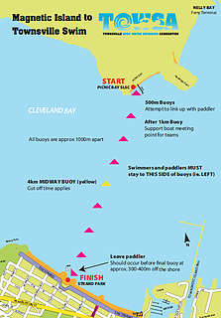

There are certain control points:
- Paddlers and swimmers should meet up by the 1km buoy. Swimmers should not proceed past this point without a paddler.
- All Support Boats should have identified their paddler/Swimmer by the 2km point.
- 4km yellow buoy at half way - cut off time of 1hr 35m.
- Final buoy approximately 200 m off the Strand Park beach finish.
Straight line v reality. Support boats should stay well clear of the Picnic Bay fringing reef.
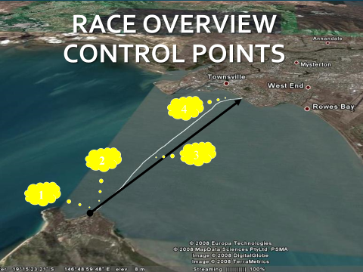
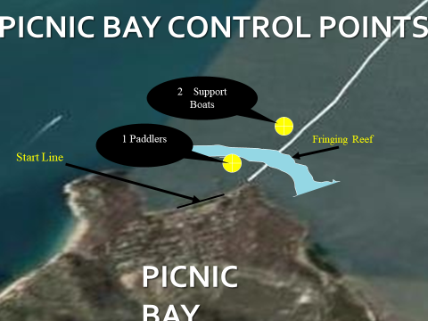

START:
In the water start about knee deep. Be aware of small rocks as you walk in.
Siren start.
You will be then be swimming over Picnic Bay reef.
SOLO swimmers will start first then DUO & RELAY 10 minutes later.
Recommend slower swimmers to the back or side.
FIND YOUR SWIMMER: Paddlers, think about how you and your swimmer will identify each other amongst the other swimmer/paddlers. Paddlers must meet up with their swimmer by the 1km control point. The most ideal positioning of paddler is on the breathing side of the swimmer.
Duo & teams – paddler could be near by the start to make it easier to see your swimmer.
Duos / Teams may swap when they want to, but safety first.
Tide will provide sufficient depth over the reef but don’t get distracted.
LAND MARKS
Swimmer can see Castle Hill, The Aquarius, Picnic Bay Surf Club Headland, Pallarenda on you right. The paddler should be looking for the next buoy.
OFFICIAL’S BOAT
Will follow swimmers, ensure fair race, provide radio reports back to the beach, and enforce cut-off times (1hr 35m / 3 hr 15 mins)
The Police Boat may also be on the water
BEACH FINISH
Finish Shute on the beach with electronic timing.
Expected Finish Times between 9.20 and no later than 11.05 am
Swimmers: keep the last buoy on your right shoulder, paddlers keep out of finish area, escort boats – restricted area 400m offshore.
Your timing chip will be collected as you cross the finish line into the recovery area.
RELAY & DUO FINISH - Swimmer with timing chip will cross the line. Other swimmers may swim into the beach with them.
There will be your family and friends, TOWSA MC, as well as Media at the finish to do interviews. I hope you have the energy left to smile for the photographers.
A tent will be set up for Recovery, First–aid or assistance if needed and to collect your bags.
PRESENTATIONS
Townsville Picnic Bay Surf Lifesaving Club will be open for all day breakfasts.
Presentations and celebrations will be held later in the day a venue to be announced. Most likely The Drill Hall Studio from 5pm. Prizes will be awarded to the overall Male and Female winners, 2nd & 3rd, Age Group 1st, 2nd and 3rd male and female, winning wet suiter, and winning duo & team.
Thank you to Sponsors, Organising Committee Members, Townsville Triathlon Club, Townsville Tourist Swim Club, the Surf Lifesaving Clubs, Paddlers, Townsville Amateur Radio Club, Boaties, Ray Boundy, Rhino Dive, Paul Vettel, Dave Meurant and all those who have helped with the 2024 Salt 66 Magnetic Island to Townsville Swim.

